MOORES CREEK

NATIONAL BATTLEFIELD

TEACHERS MANUAL

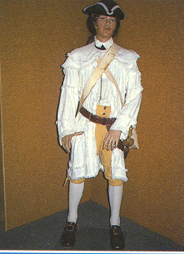
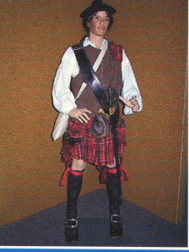

vs
PATRIOTS LOYALISTS

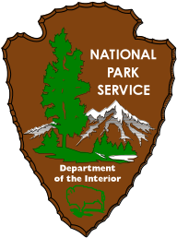
EXPERIENCE YOUR AMERICA
The National Park Service cares for special places
saved by the American people so that all may
experience our heritage.
Table of Contents

Introduction 3

Location 4

Facilities 5

Preparing for a Visit 7

Rules 8

General background of North Carolina 9

African Americans in the Revolution 11

Women in the Revolution 13

Vocabulary 15

The Militia 16
Patriot Militia 17
Weapons and Supplies 18
Loyalist Militia 19
Old Mother Covington and her Daughter 20

Teaching Material 21
The Battle of Moores Creek 22
4th Grade Review Questions 24
Word Search 26
Word Scramble 28
8th Grade Review Questions 30
Bibliography 32

Introduction

This guide is designed to help teacher's present 4th and 8th grade level material about the American Revolution and the Battle of Moores Creek. However, this material can be adapted to fit any grade level. The text portions are for your use in preparing lessons. The activity pages are designed for student use. This guide was developed using the North Carolina Curriculum Objectives and with the help of area teachers.

Visiting Moores Creek is not required when using this guide but we believe that learning is enhanced when students interact with the environment. To make a reservation, please call (910) 283-5591 or write

Moores Creek National Battlefield
40 Patriots Hall Drive
Currie, North Carolina 28435

Location

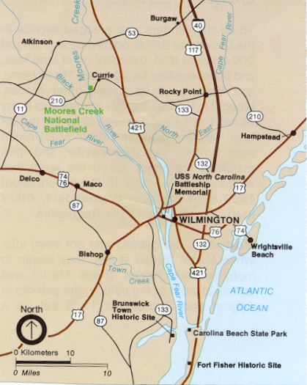
Moores Creek Battlefield is located twenty miles northwest of Wilmington, NC. From Wilmington take I-40 or US 421 north to the junction with NC 210; go west on 210 to the park entrance on the right. The battlefield is open daily except for January 1 and December 25. Hours are 9a.m to 5p.m. Contact the park staff in advance to arrange programs and guided tours.

Moores Creek Facilities
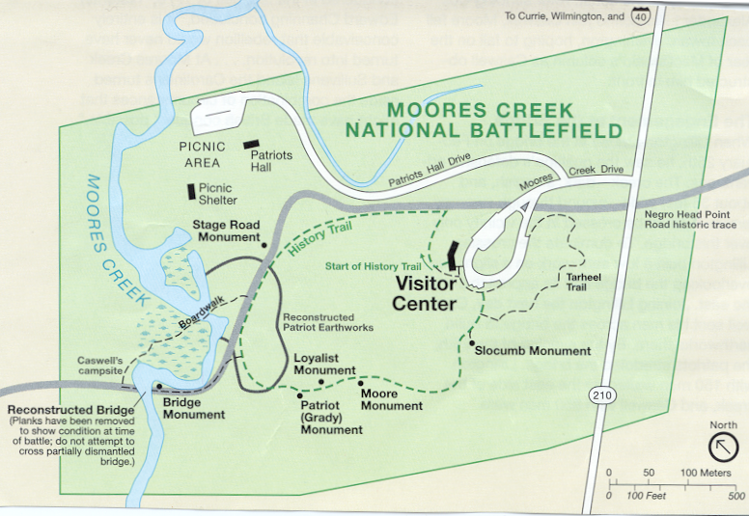

Visitor Center

In the Visitor Center you can view a 12-minute audiovisual program about the battle, see Revolutionary War weapons such as the Brown Bess musket, Highland pistol, broadsword, and a half-pound swivel gun, and get information on the Patriot and Loyalist militia. Also located in the visitor center is a bookstore and gift shop. The sales area can accommodate only 10 students at a time when shopping the bookstore and gift shop.

Rest rooms and water fountains are located outside of the visitor center in a separate building. A drink machine is located next to the restrooms.

Trails

Moores Creek has two handicapped accessible walking trails. The History Trail is about 1 mile in length, and follows, for a short distance, the old Negro Head Point Road. This is a historic road Loyalists used during the battle. A boardwalk crosses Moores Creek and takes you to the West Bank where the Patriots camped first. The West Bank also provides the Loyalists’ view of the bridge as they moved up the road.

Crossing the bridge, you approach the earthworks. While standing in the encampment area you can view the bridge from the Patriots’ side.

The Tarheel Trail is .3 miles in length and explains the production of naval stores, such as tar, pitch, turpentine, and rosin, which are the products of longleaf pine trees. The British needed naval stores to maintain the wooden ships in their Navy. Naval stores were the chief industry in this region during the American Revolution.

Monuments

On the history trail, six monuments honor events and people connected to the site. The first is the Stage Road Monument, marking Negro Head Point Road. Loyalists, coming from Cross-Creek (Fayetteville), used this road to travel to Fort Brunswick where they were to meet British forces. The second monument, The Battle of Moores Creek Bridge, recognizes the bridge and causeway where the battle was fought. The Patriot Monument honors the Patriot militia and John Grady, the only Patriot to die as a result of the battle. The Loyalist Monument honors the soldiers “who did their duty as they saw it.” The Moore Monument honors the first president of the Moores Creek Battleground Association. Finally The Women’s Monument honors the Women of the Lower Cape Fear Region who helped with the Patriot cause.

Picnic Area

At the end of Patriots Hall Drive, is the picnic area with outdoor tables and an open-air shelter. Adjacent to the picnic shelter is a large grassy area, water fountain, and restrooms. The picnic shelter and tables are available on first come, first served basis.

Patriots Hall Education Complex and Musket Firing Range

Patriots Hall can accommodate up to 250 people for the interpretive program. The musket firing range is located behind Patriots Hall.

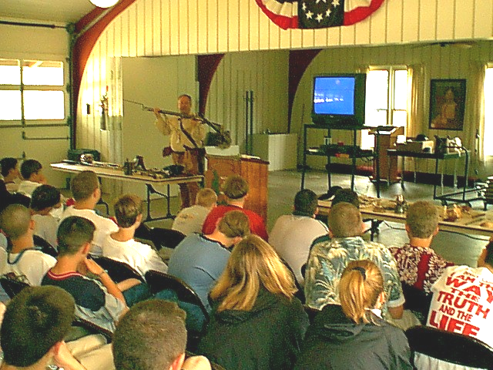
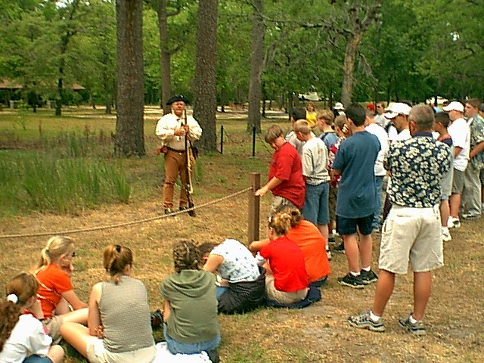

Preparing for a Visit

Prior to your visit, we ask that you briefly discuss the following topics.

- Events leading to the Revolution
- North Carolina in the Revolution

Women in the Revolution
- African Americans in the Revolution
- Civil conflict between the citizens of North Carolina
- Events leading to the Battle of Moores Creek

For 8th grade classes we recommend viewing North Carolina in the American Revolution, a 20-minute video. You can stop by and borrow a copy or you can request that it be sent to you. If we mail the video, you will be required to pay the return postage fee.

While visiting Moores Creek National Battlefield, we require the following:

1. There must be one adult for every ten children.

2. Walk, don’t run.

3. Look where you’re going, not where you’ve been.

4. Watch where you stand. Fire ants live here.

5. Watch where you lean or put your hands. Poison ivy grows well here.

6. Stay off the earthworks – raised earth mounds that surround the battlefield.

- Stay off the creek bank and out of the creek.

8. While on the boardwalk, stay on the walking surface. Do not walk on the handrails or crawl
through the handrails.

- Gum and candy wrappers are litter.

- No screaming. Other people are visiting the park too.

- Use extra respect in everything you do on the causeway, battlefield and monument area.
Men fought and died in these locations. We view these areas as “hallowed ground” and
remind you to respect it accordingly.

12 No food, drinks, or gum are allowed in the Visitor Center.

13. Have a great visit.

General Background of North Carolina

In the 1700s, thousands of immigrants poured into North Carolina. Some people came to North Carolina from American colonies to the north and south. Many of them brought enslaved Africans with them. However, most people who settled in North Carolina in the mid-1700s came from Scotland, Ireland, and Germany. Each set of newcomers followed a different dream – adventure, cheap land, religious or political freedom, economic opportunity, and more. These dreams led people to fill up lands from the Coastal Plain to the foot of the Appalachian Mountains. A few hardy pioneers even pushed across the Appalachians, seeking new frontiers to cross. By 1776, North Carolina ranked fourth among the colonies in population.

Moving into Cape Fear. Turmoil in the British Isles drove the Scottish Highlanders from Scotland to North Carolina. England ruled the independent-minded Scots with a tight fist. Gabriel Johnston, a Scot, became royal governor of North Carolina in 1734. He promoted settlement of the colony and made sure that the call for settlers reached his homeland of Scotland at an early date.

In 1740, the first large group of Scottish Highlanders landed at Brunswick near Wilmington. Numbering about 360, the Highlanders were welcomed by Johnston. He convinced the colonial Assembly to pass a law that excused Protestants from other countries from paying taxes for ten years. The Scots were one of the groups to benefit from this law. Johnston also made it possible for the Highlanders to obtain large land grants in what is now the Upper Cape Fear region of North Carolina.

The Highlanders found a haven in North Carolina just in time. In 1746, Highlanders in Scotland rebelled against England. In the defeat that followed, the English government seized huge chunks of Scottish farmland and gave it to English army officers as grazing land for sheep. Many Highlanders faced near starvation. Inspired by letters from their friends in North Carolina, they moved to Upper Cape Fear by the thousands. The region became so heavily populated that the North Carolina assembly created a new county in the region called Cumberland.

When revolution swept through the 13 colonies, the once rebellious Highlanders remained loyal to England. Perhaps they feared that losing the Revolution would result in the same harsh treatment they received from the English at home. Or perhaps the Highlanders did not want to risk losing a profitable trade in naval stores-tar, pitch, and turpentine. Whatever the reason, when rebellion came in 1776, the Highlanders refused to turn their guns against England.

Settlers against their will. People of African descent played a role in North Carolina history from the very start. Records show that Sir Francis Drake may have left enslaved Africans at Roanoke Island in 1586. If so, their fate is just as mysterious as that of the 1587 Lost Colony. Also, the original Proprietors of Carolina wrote slavery into their first plan of government.

Slavery never took as firm a root in North Carolina as in South Carolina. Of all the southern colonies, North Carolina had the smallest population of enslaved Africans. Hampered by a lack of good ports, North Carolina failed to develop an active slave trade. Moreover, the small farmers of the Piedmont had little need for slaves, and the plantations of coastal North Carolina never reached the same scale as those of South Carolina, Virginia, and Maryland.

The outspoken Quakers who lived in large settlements in the central part of North Carolina further limited the effects of slavery. They urged slaveowners to treat Africans well and to allow them to attend church. In 1770, North Carolina Quakers described the African slave trade as “an iniquitous [sinful] practice” and called for an immediate end to it. Few slaveowners heeded this call. Nonetheless, North Carolina slaves faced less brutality than those who labored on the rice plantations farther south.

Education

In early days of settlement, most children received their education from their parents. Schooling consisted of little more than reading, writing, and “figuring,” as arithmetic was sometimes called. Slowly, however, parents pooled their money and built log schools. Teachers, paid by the commuity, taught students of all ages in what amounted to one-room cabins.

By the mid-1700s, academies had been established to prepare students for higher learning. One of the most famous of these was the Reverend David Caldwell’s “seminary of learning,” built in 1767 at present-day Greensboro. Caldwell’s school prepared hundreds of boys and girls for fuller lives.

Students desiring a university education still had to head off to colleges in England, to the College of William and Mary established in Virginia in 1693, or to colleges in the Middle Colonies of New England. This situation changed in 1795 when the University of North Carolina opened its doors.

Chores

Children who were not from wealthy families had to complete daily chores that were necessary for their family’s survival. This included chopping wood, feeding farm animals, hunting, gathering vegetables, and making sure the kitchen fire did not go out. For a young boy, learning how to shoot a musket was important because it kept predators out of the fields and put meat on the table.

Children had little time to play because of the daily chores they had to complete. Children from a small family had less time for play, while families with more children could distribute the work more evenly. When children had completed their chores they were free to play. Typically, boys played with kites, checkers, and marbles. Girls played with dolls, jumped rope, and bobbed for apples.

Life in the colonial period was much harder than our life today. Children had a lot of responsibility at an early age. The family’s survival depended on everyone to help with the work.

African Americans in the Revolution

In the Service of King or Country

Efforts by African Americans to organize resistance to the Revolutionary movement by taking up arms or fighting for the British met fierce and swift retaliation in Virginia, North Carolina, and South Carolina in 1775-1776. The quest for freedom was undiminished, but greater caution and calculation had to be exercised. Moreover, not all African Americans sided with the British. Many rallied to the American cause. Indeed, freed slaves appear to have had a greater propensity for joining the Continental Line or state militias than joining the British army. Slaves, on the other hand, flocked to the British, in part because of the Patriots’ misgivings about arming them, and too because the British seemed to offer the better chance for freedom. In either case, African Americans provided significant manpower to both sides in the Revolutionary struggle.

War’s end brought further gain to blacks. To the slave soldier who had borne the responsibilities of citizenship before he could enjoy its rights, it brought freedom and in some instances, a land bounty. In New Jersey, slaves belonging to the Loyalists were freed by an act of the legislature.

Crispus Attucks

Crispus was a runaway slave who was part African American and part Indian. On the night of March 5, 1770, Crispus was in a large crowd that had gathered around a soldier stationed at the Boston customhouse. The crowd accused the soldier of using the butt of his musket on a boy who uttered a slur about a British officer. The British soldier loaded his gun, backed up the steps, and called for help. British reinforcements arrived, and the crowd grew rowdier. Crispus knocked the soldier’s gun away and hit him over the head with a club. The rest of the soldiers fired into the crowd, killing Crispus and two others. Another eight were wounded. This revolt was known as the Boston Massacre.

Peter Salem

Peter Salem was granted his freedom so he could enlist to fight for the Patriots’ cause during the American Revolution. In the 1775 Battle of Bunker Hill, he became a hero. He killed British Army Major Pitcairn (first name unknown) and was brought before General George Washington for his heroism. He also participated in the battles at Lexington, Saratoga, and Stony Point.

Phyllis Wheatley

Phyllis was a slave owned by the Wheatley family of Boston. She was taught to read and write. In 1770 she published her first poem and three years later she published her first book of poems. Phyllis Wheatley was the first African American to publish a book, giving her international fame. Her poems were about tyranny and freedom, but she also wrote poems about people. She wrote a poem praising George Washington. George Washington loved the poem and wanted it published. However, he felt that if he had it published, people would misconstrue his purpose in doing so. In April 1778, Phyllis married John Peters, a prominent African American. She continued to write poems until the day she died at the age of thirty-one.

Felton

Felton was an African American from Surry County, North Carolina who participated in the Battle of Moores Creek. Felton served under Captain William Sheppard and Colonel Joseph Williams. He guarded prisoners and disarmed the Loyalists in the aftermath of the battle. Whether Felton was his first or last name is unknown. He is believed to have been a free slave because of some of the military duties assigned to him.

Isaac Hammond

Isaac Hammond, a free black, was a barber in the Fayetteville, North Carolina community. He served honorably in the 10th Regiment of the NC Continental Line during the American Revolution. Shortly after the Fayetteville Independent Light Infantry was organized in 1793, Isaac Hammond became the first Company Fifer. He was buried, with full military honors, at the Old Parade Grounds on the banks of Cross Creek in Fayetteville.

Women in the Revolution

Men were not the only ones involved in the revolution. Before the war it was considered unladylike for women to voice their beliefs or opinions in public.

During the Revolution women’s roles changed. Women began to speak more openly about the political aspects of life. They gave up their elaborate gowns and sometimes their homes for the cause of the revolution. Some women worked in hospitals; many were left to run businesses, farms or plantations. Some formed organizations to renounce the use of tea and other imported items. Below are the stories of some of the important women from this time period.

Mercy Ottis Warren

Mercy was an intelligent, educated woman. At the beginning of the Revolution, when women were not allowed to speak of political issues, she expressed her views and thoughts by writing books and poetry. Her works were published anonymously because she was a woman. If the British troops had discovered her identity, she could have been imprisoned. In addition, Mercy became an advisor to her brother, James Ottis, and his friends, Samuel Adams and John Hancock. Thanks to the political writings of Mercy, anti-British sentiment grew in the colonies. After independence was won, Mercy made a final contribution to her country with her book History of the Rise, Progress, and Termination of the American Revolution.

Rebecca Motte

Rebecca Motte lived in a mansion outside Charleston, South Carolina. She was forced to surrender her home to the British and move into an old farmhouse. The Patriots wanted to remove the British from South Carolina. Lt. Col. Lee, a patriot leader, came to the conclusion that the only way to remove the British was to burn the house down. Lt. Col. Lee did not want to burn her house because Rebecca’s husband had contributed greatly to the cause. After consulting with Rebecca he found that she was glad to help out in any way she could, even though it meant losing her home. Legend has it that she gave the Patriots the arrows used to set it afire.

Penelope Barker

On October 25, 1774, Penelope Barker and fifty-one patriotic ladies living in Edenton, North Carolina signed a Proclamation stating that they had a duty to become involved in the political issues affecting the colonies. The ladies decided to back the boycott of British goods. They stopped drinking tea and wearing clothes that came from Great Britain. This event became known as the Edenton Tea Party.

Vocabulary

- Boycott- the refusal to buy, sell, or use certain goods or services.

2. Cross Creek- present day Fayetteville

- Loyalists- people loyal to Britain

- Militia- an army composed of citizens who are not professional soldiers, usually called in
an emergency

- Patriots- people who wanted Independence from Britain

- Revolution- a great or sudden change

- Stamp Act- tax (1765) on paper goods such as deeds, licenses, playing cards, and
newspapers

- Tax- money people pay to support their government

The Militia

The Battle of Moores Creek Bridge was fought between two militias. A militia is an army composed of citizens who are not professional soldiers. Colonial North Carolina had no standing army so militias were the only protection available. All free males, regardless of race, between the ages of 16 and 60 were required to join the militia. Muster, or drill, was held every month or so. Militiamen received pay only when they were in the field under the direction of the colonial Assembly. The officers in the militia were elected by the General Assembly.

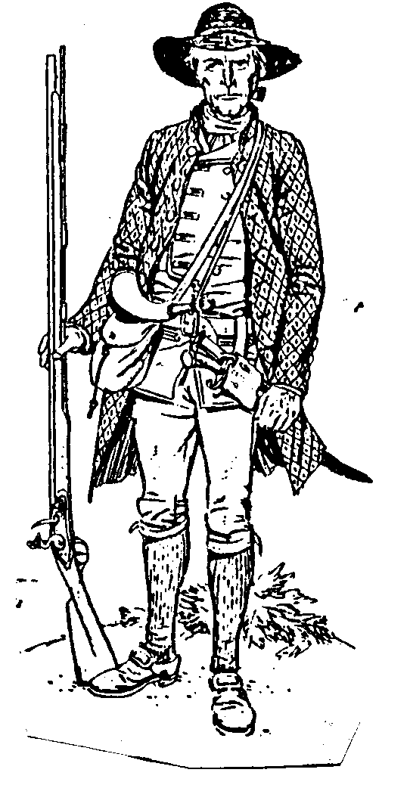
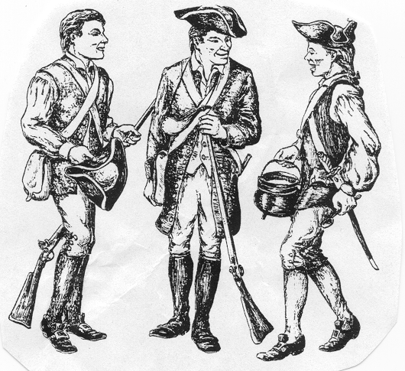
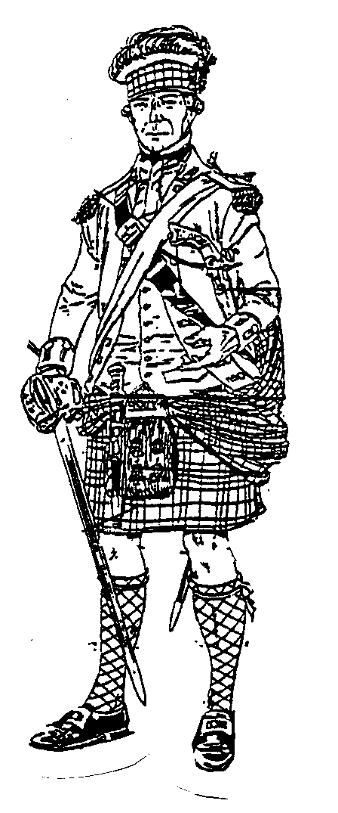
Militiamen were required to provide their own equipment, including a musket, gunpowder, clothes, food, cartridge box, and canteen. Patriot soldiers usually wore civilian or hunting clothes. Most of the clothing was tan or brown, the color of cloth that was produced in the colonies. The majority of the Loyalists who fought at Moores Creek were Scottish Highlanders. They would have worn their traditional plaids, if they had them, while other Loyalists wore English-style clothing. On the next few pages you will find examples of the clothing that was worn and the equipment used by militias.

Patriot

Colonial Militia and Minuteman

Loyalist

Patriot Militia

The Patriots were citizens who wanted freedom from Britain. To be in the militia, you had to be sixteen or older. Militiamen had to use their own equipment and weapons. The Patriots usually carried the following items.
- “Brown Bess” Musket- English firearm made between 1720 and 1840.
- Bayonet- a spear-like weapon used on the end of a musket.
- Cartridge Box- a leather pouch to carry cartridges of gunpowder and shot used in a musket.
- Tomahawk- a light ax first used by the North American Indians.

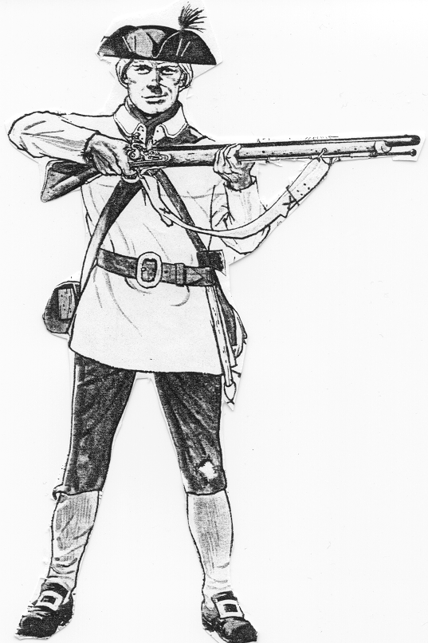
Tricorn Hat

Cartridge box
Brown Bess Musket
Tomahawk

Weapons and Supplies

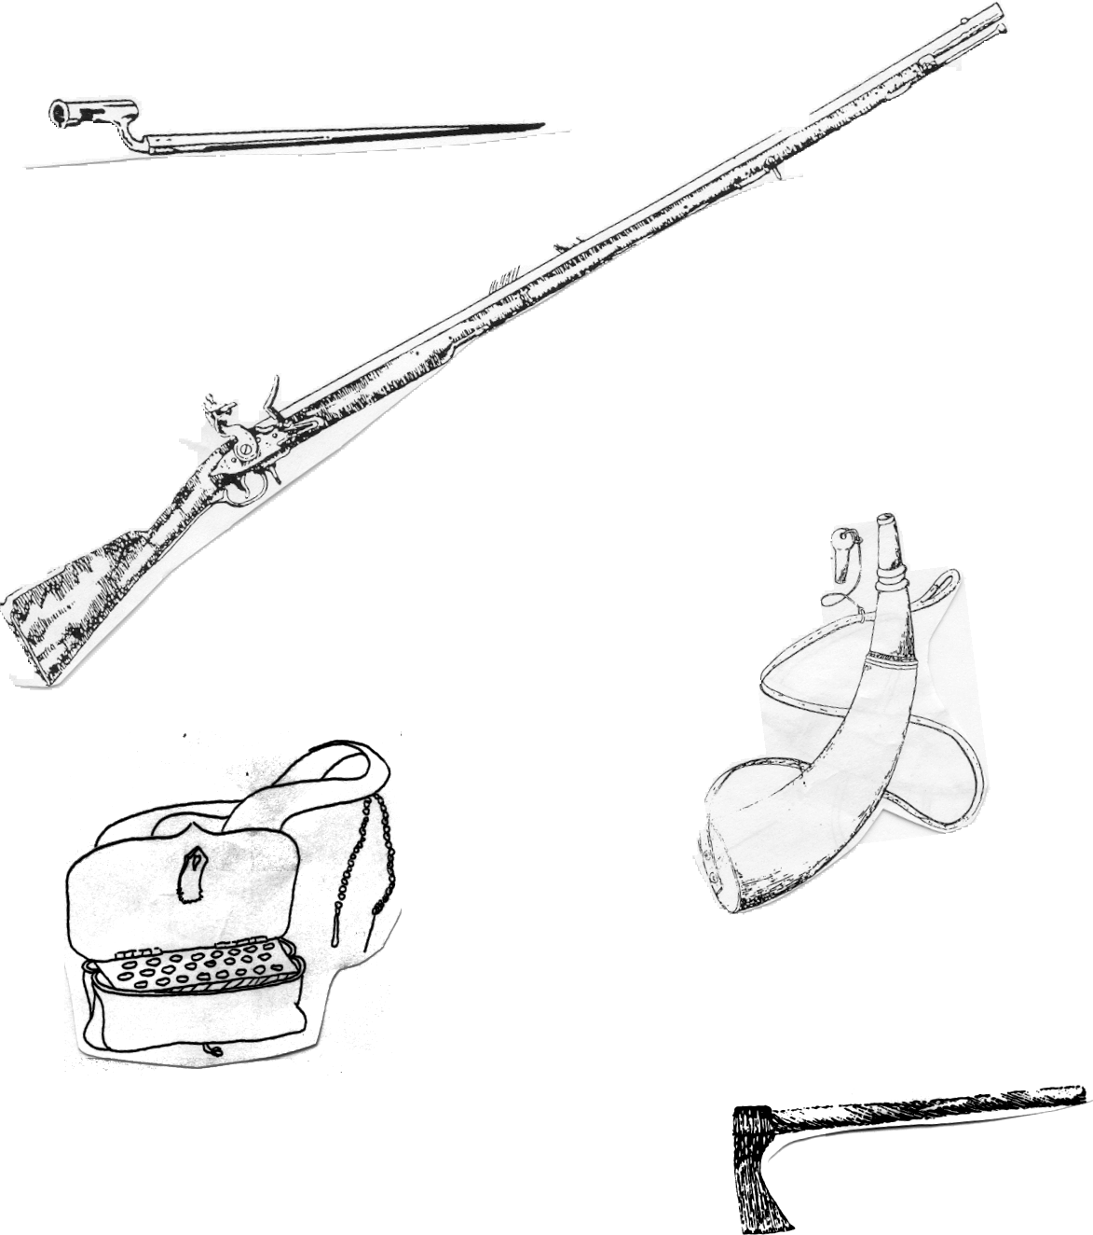
Bayonet
Brown Bess Musket
Powder Horn
Cartridge Box
Tomahawk

Loyalist Militia

Some of the Loyalists of North Carolina were Scottish Highlanders. The Highlanders were known for their fearless battle tactics. They liked to fight close up (hand to hand combat). It has been said that the Scots greased themselves, cut their hair, and shaved their beards so the enemy would be unable to hold onto them in battle. The Scots used some of the following items.
- Kilt- a knee-length garment with deep pleats, usually made of (plaid) wool.
- Dirk- a straight bladed dagger.
- Sporran- a leather pouch or purse.
- Broadsword- a large double-edged sword.
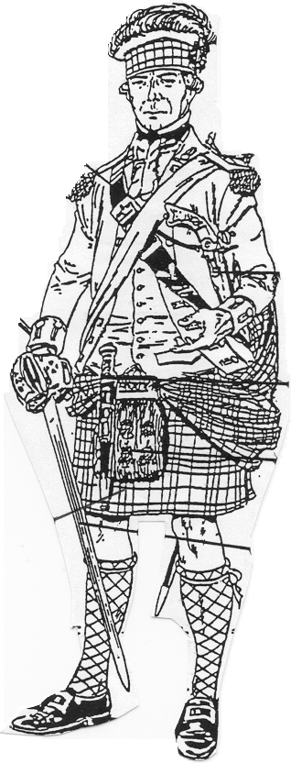
- Highland Pistol- an all-metal, single-shot pistol.

Bonnet
Sword Belt
Highland Pistol
Dirk
Sporran
Broadsword
Kilt

“Old Mother Covington and Her Daughter”

During the Battle of Moores Creek, the Patriots had a distinct advantage over the Loyalists. The Patriots had at least two pieces of artillery that they called “Old Mother Covington and her daughter”. Old Mother Covington was a 2 ½ pound cannon mounted on a galloper carriage. The Daughter was a ½ pound swivel gun. Swivel guns were usually mounted on tree stumps. The swivel gun was easy to move and set up.

Both pieces of artillery were loaded with swan shot. Swan shot was a canvas bag filled with 20 to 25 small pieces of shot (about 1/8-inch diameter lead pellets). When fired, swan shot spreads over a wide area, much like a shot-gun. The Loyalists had little chance for victory with the Patriots’ artillery aimed directly at the bridge.
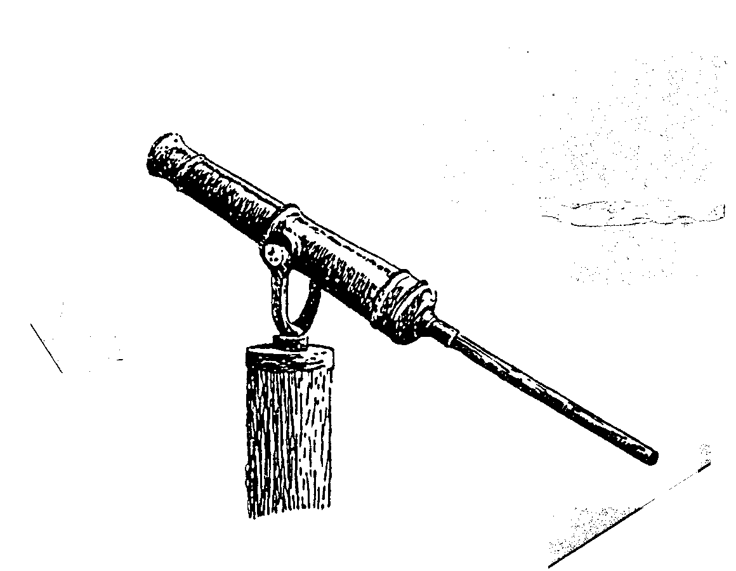
Swivel gun with socket for tiller.

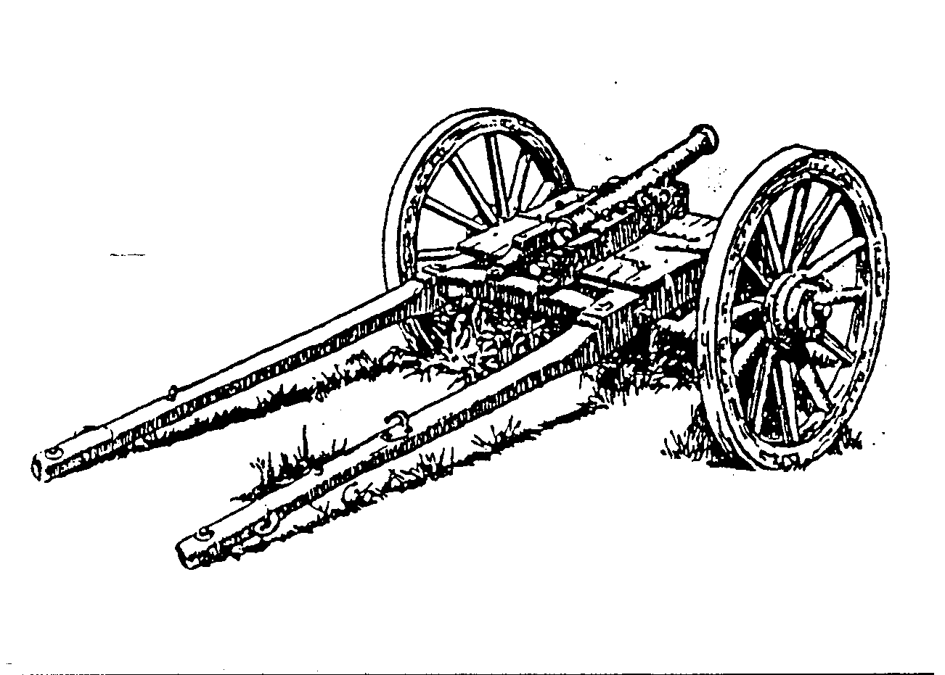
English Galloper carriage and gun.

Teaching

Material

THE BATTLE OF
MOORES CREEK

North Carolina was first governed by a Legislative body know as the General Assembly. The colonists elected members to that Assembly. However, in 1721 the British appointed a Royal Governor to control North Carolina. Disputes erupted between the Royal Governor and the General Assembly. The colonists became angry because the governor could overturn any law the assembly passed. They were forced to abide by laws they had no part in making. Colonists also had no representation in the British parliament.

The British told the colonists whom they could trade with and instructed them to form militias for the governor’s use. The British began to tax the colonies for paper goods and tea in order to pay off debts incurred during the French and Indian War. Revolts against taxation began to occur throughout the colonies including North Carolina. The colonists began to separate into groups: the Patriots who opposed the British and the Loyalists who supported the crown.

In 1775, disputes between Josiah Martin, North Carolina Royal Governor, and the colonists became unbearable. As a means of discouraging the use of force by Martin, the Patriot militia companies were called out in New Bern and the surrounding countryside, with the avowed purpose of opposition to royal authority. With the mounting wave of resistance forecasting violence and upheaval, the governor began to fear for his life. Gov. Martin fled Tryon Palace (his home) in New Bern, to a British ship off the coast of Wilmington. Safe on the ship, Martin developed a plan to re-take North Carolina. His plan called for Britain to send troops while he recruited Loyalists in the area. The Loyalists were to rendezvous with the British troops in Brunswick, near Wilmington. Gov. Martin would supply weapons to the Loyalists and lead them in subduing North Carolina and returning it to British rule.

Gov. Martin believed 10,000 Loyalists could be recruited in the colony. The governor had friends in Cross Creek (Fayetteville), so he sent Alexander McLean to recruit his supporters there. Along with McLean, two British army officers, Gen. Donald MacDonald and Capt. Donald McLeod (Scottish Highlanders) were sent to Cross Creek because of their ability to speak Gaelic. Cross Creek had been settled by Scottish Highlanders, and their native language was Gaelic. At Cross Creek they recruited only 1600 Loyalists to fight, the majority of whom were Scots. These Scots were to receive 200 acres of land, would not have to pay taxes for 20 years, and be reimbursed for the supplies they used. The Loyalists then set out for the coast near Wilmington.

The Patriots learned of Martin’s plan. Three officers were deployed: Colonel James Moore, Colonel Richard Caswell and Colonel Alexander Lillington. Colonel Moore, the commander, blocked the most direct route to the sea at Rockfish Creek near Cross Creek. When Moore had established his troops there, Gen. MacDonald and the Loyalists were forced to use Negro Head Point Road, a route that crossed Moores Creek. Col. Lillington and his 150 minutemen were sent to block Moores Creek Bridge. Lillington’s men built earthworks on the east bank of the creek, in sight of the bridge. Caswell and his 850 militiamen were the next to arrive at the creek. They brought two pieces of artillery. Old Mother Covington was a 2 ½ pound cannon and her "daughter" was a ½ pound swivel gun. Col. Caswell and some of his men set up camp on the west bank of the creek.
Meanwhile, the Loyalists had traveled within six miles of the bridge. The Loyalists sent a messenger to the Patriot camp under a flag of truce. The messenger informed the Patriots that they would be pardoned if they would surrender and declare their loyalty to the king. The Patriots refused and sent the messenger back. However, the messenger had secured important information. He reported to MacDonald that the Patriots were camped with the creek to their backs. Gen. MacDonald who wanted to move his troops to the coast without engaging in battle, fell ill, and Capt. McLeod assumed command of the Loyalists.

Later that evening, Caswell moved his men to the east bank of the creek joining Col. Lillington’s Patriots. After everyone was across, Caswell’s men removed some of the planks from the bridge. They left the tents up and the campfires burning on the west bank to make the Loyalists believe they had just left the camp.

On February 27, 1776 at 1 am, the Loyalists started their march to Moores Creek. They arrived at daybreak to find Caswell’s camp empty. McLean saw some men on the other side of the bridge. The men asked McLean if he was a friend. McLean replied, “ to the King.” The men fell back to the earthworks. McLean then called out to the men in Gaelic. There was no reply. He realized the men were Patriots and reported this to Capt. McLeod.

Capt. McLeod rallied his troops and moved to the bridge, where he discovered that the planks had been removed. To the cry of, “King George and Broadswords,” the Loyalists crossed the girders. As they charged along the causeway, they met the cannon and musket fire of the Patriots. Loyalists fell along the road and on the bridge, some drowning in Moores Creek.

Within minutes the battle was over. Over 30 Loyalists were killed, including Capt. McLeod. One Patriot, John Grady, died from wounds sustained in the battle and one other was injured. The remaining Loyalists fled for safety. Some of them were captured and imprisoned, including Gen. Donald MacDonald. The Patriots, who numbered about 1000, had defeated 1600 Loyalists.

After the battle, captured Loyalists who were not officers were released after taking an oath not to raise arms against the Patriot cause in the future. The officers, however, were in- carcerated in Halifax, North Carolina, which was soon bulging with Loyalist prisoners of war.

The Patriot victory at Moores Creek, convinced North Carolina to instruct its delegates to the Second Continental Congress to vote for independence from Great Britain. This made North Carolina the first of the colonial governments to call for total independence.

In May 1776, The British fleet, after battling high winds and heavy seas for more than two months, finally dropped anchor in the Cape Fear River. After hearing of the Patriot victory at Moores Creek Bridge, the British fleet sailed for Fort Sullivan, near Charleston, South Carolina. On June 28, the British ships opened fire upon the half-completed fort and its 413 patriot defenders. From 11:00 A.M. to about 9:30 P.M., the British ships continuously fired, and the patriots returned fire with their twenty-five guns.

The fort’s palmetto logs did not splinter when hit and the sand absorbed the shots. The British fleet abandoned the fight and sailed to the North where the war would be fought for the next four years. The British would not invade the South again until 1780.

1. In what year did the first large group of Scottish Highlanders come to Brunswick?

a. 1640 b. 1940
c. 1740 d. 1841

__ 2. In what year did the University of North Carolina open its doors?

a. 1785 b. 1795
c. 1765 d. 1755

__ 3. How many Loyalists did Governor Martin believe he could recruit?

a. 1100 b. 1000
c. 10,000 d. 1600

__ 4. How many Patriots were at the battle of Moores Creek Bridge?

a. 800 b. 950
c. 1000 d. 1150

__ 5. The Royal Governor was a friend of whom?

a. People b. King c. General Assembly

__ 6. Who was the Royal Governor of North Carolina in 1775?

a. Josiah Martin b. Richard Caswell c. Donald MacDonald

__ 7. Where were the Loyalists to meet Martin and the British reinforcements?

a. Wilmington b. Cross Creek c. Brunswick

__ 8. What were the mounds of dirt called that the Patriots built at Moores Creek?

a. earthworks b. muskets c. boxes

__ 9. Who won the Battle of Moores Creek?

a. Scots b. Patriots c. Loyalists

__ 10. Why is the Battle of Moores Creek important?

- First decisive Patriot victory
- Convinced North Carolina to call for independence
- All of the above

C 1. In what year did the first large group of Scottish Highlanders come to Brunswick?

a. 1640 b. 1940
c. 1740 d. 1841

D 2. In what year did the University of North Carolina open its doors?

a. 1785 b. 1795
c. 1765 d. 1755

C 3. How many Loyalists did Governor Martin believe he could recruit?

a. 1100 b. 1000
c. 10,000 d. 1600

C 4. How many Patriots were at the battle of Moores Creek Bridge?

a. 800 b. 950
c. 1000 d. 1150

B 5. The Royal Governor was a friend of whom?

a. People b. King c. General Assembly

A 6. Who was the Royal Governor of North Carolina in 1775?

a. Josiah Martin b. Richard Caswell c. Donald MacDonald

C 7. Where were the Loyalists to meet Martin and the British reinforcements?

a. Wilmington b. Cross Creek c. Brunswick

A 8. What were the mounds of dirt called that the Patriots built at Moores Creek?

a. earthworks b. muskets c. boxes

B 9. Who won the Battle of Moores Creek?

a. Scots b. Patriots c. Loyalists

C 10. Why is the Battle of Moores Creek important?

- First decisive Patriot victory
- Convinced North Carolina to call for independence
- All of the above

R | T | A | R | T | I | L | L | E | R | Y | V | M | B | O | C | S | A
E | I | B | Z | F | G | L | M | J | P | V | A | D | O | E | L | C | M
V | U | C | E | B | R | I | T | I | S | H | C | O | Y | N | I | Z | A
O | R | C | H | P | A | A | R | C | P | S | N | X | C | Z | B | X | C
L | V | B | D | A | B | V | D | F | A | R | U | I | O | T | X | O | D
U | F | T | H | T | R | E | L | O | O | P | N | S | T | A | J | E | O
T | R | R | Y | R | P | D | O | L | L | U | M | C | T | K | L | I | N
I | N | D | A | I | B | R | C | O | W | N | H | A | T | T | I | E | A
O | S | Q | U | O | I | R | E | A | N | S | T | E | T | R | E | S | L
N | A | G | R | T | I | F | F | O | S | I | N | T | R | S | A | C | D
Y | C | A | R | S | R | S | T | H | E | W | A | H | A | R | P | E | R
A | N | N | C | H | I | G | L | D | R | E | E | S | S | T | O | M | O
R | R | O | W | F | N | L | A | G | S | T | A | L | N | L | E | N | Y
S | K | Y | Z | I | S | T | S | I | L | A | Y | O | L | A | C | O | Y
E | R | Y | L | G | R | A | D | U | A | T | I | O | P | H | I | N | S
S | I | L | R | A | L | M | I | L | I | T | I | A | W | A | Y | N | S
S | I | I | N | K | E | E | R | C | S | E | R | O | O | M | G | A | N
L | O | C | R | O | S | S | C | R | E | E | K | V | E | M | B | C | E

WORD SEARCH

Richard Caswell Militia MacDonald Moores Creek

Patriots Stamp Act British Tax

Revolution Loyalists McLeod Artillery
Boycott Cross Creek Lillington Cannon

R | T | A | R | T | I | L | L | E | R | Y | V | M | B | O | C | S | A
E | I | B | Z | F | G | L | M | J | P | V | A | D | O | E | L | C | M
V | U | C | E | B | R | I | T | I | S | H | C | O | Y | N | I | Z | A
O | R | C | H | P | A | A | R | C | P | S | N | X | C | Z | B | X | C
L | V | B | D | A | B | V | D | F | A | R | U | I | O | T | X | O | D
U | F | T | H | T | R | E | L | O | O | P | N | S | T | A | J | E | O
T | R | R | Y | R | P | D | O | L | L | U | M | C | T | K | L | I | N
I | N | D | A | I | B | R | C | O | W | N | H | A | T | T | I | E | A
O | S | Q | U | O | I | R | E | A | N | S | T | E | T | R | E | S | L
N | A | G | R | T | I | F | F | O | S | I | N | T | R | S | A | C | D
Y | C | A | R | S | R | S | T | H | E | W | A | H | A | R | P | E | R
A | N | N | C | H | I | G | L | D | R | E | E | S | S | T | O | M | O
R | R | O | W | F | N | L | A | G | S | T | A | L | N | L | E | N | Y
S | K | Y | Z | I | S | T | S | I | L | A | Y | O | L | A | C | O | Y
E | R | Y | L | G | R | A | D | U | A | T | I | O | P | H | I | N | S
S | I | L | R | A | L | M | I | L | I | T | I | A | W | A | Y | N | S
S | I | I | N | K | E | E | R | C | S | E | R | O | O | M | G | A | N
L | O | C | R | O | S | S | C | R | E | E | K | V | E | M | B | C | E

Richard Caswell Militia MacDonald Moores Creek

Patriots Stamp Act British Tax

Revolution Loyalists McLeod Artillery
Boycott Cross Creek Lillington Cannon

WORD SCRAMBLE

N L R I O O V U E T ________________

Y T B O T O C ______________________

X T A ______________________

T P S T O I R A ___________________

P T M A S T C A ______________________

Y L L O A S T S I ______________________

A I T L I I M ______________________

S O R C S E K R C E ______________________

Y R A L T R I E L ______________________

O M R E O S K C R E E _______________________

I B S H T R I _______________________

N C N A N O ____________________

WORD SCRAMBLE

N L R I O O V U E T REVOLUTIN

Y T B O T O C BOYCOTT

X T A TAX

T P S T O I R A PATRIOTS

P T M A S T C A STAMP ACT

Y L L O A S T S I LOYALISTS

A I T L I I M MILITIA

S O R C S E K R C E CROSS CREEK

Y R A L T R I E L ARTILLERY

O M R E O S K C R E E MOORES CREEK

I B S H T R I BRITISH

N C N A N O CANNON

Review Questions

- Why did the British need to tax the colonies?

- Who did the Royal Governor use for his military forces?

- Who were the Patriots and the Loyalists?

- Who was the Royal Governor of North Carolina in 1775?

- Why were the Loyalists going to Brunswick town near Wilmington?

- Name three Patriot leaders.

- Who was the first Patriot leader to arrive at Moores Creek?

- What did Caswell bring to Moores Creek that gave the Patriots an advantage?

- What did Caswell do to fool the Loyalists?

- What did the Patriots do to slow the Loyalists down?

- What offer did the Loyalists make to the Patriots the night before the battle?

- What officer fell ill prior to the battle of Moores Creek?

- What did McLean see when he arrived at the bridge?

- Why is the victory at Moores Creek Bridge important?

- What happened on April 12, 1776?
Answers

- So they could pay off debts incurred during the French and Indian War.
- Loyalist militias and Scot Highlanders.
- Patriots-citizens who opposed British rule. Loyalists-citizens supported British rule.
- Gov. Josiah Martin
- To rendezvous with British Troops.
- Col. Richard Caswell, Col. Alexander Lillington, Col.James Moore
- Col. Lillington
- Artillery
- He left his camp with the tents in place and campfires burning on the west bank of the creek.
- Removed some of the planks from the bridge
- The Patriots would be pardoned if they surrendered and declared loyalty to England
- Gen. Donald MacDonald (Loyalists)
- He saw tents, campfires burning and Patriots on the other side of the creek
14. The surprise victory at Moores Creek Bridge, coupled with unexpected patriot victories elsewhere in the south over the next few months, were critical in convincing America’s leaders to draft and sign the Declaration of Independence on July 4, 1776.
15. Congress met in Halifax. Members unanimously adopted Halifax Resolves.

Bibliography

Dictionary of American Portraits. Dover Publications, 1967.

Earle, Alice. Child Life in Carolina Days. Berkshire House, 1993.

Ellet, Elizabeth. The Women of the American Revolution. Corner House, 1980.

Fann, Marcia and Farr, Betsy. American Made: The Colonial Child of 1740. Canada, 1996.

Higgin, Miles. Pictures of Patriot Militiamen and Scottish Loyalists at Moores Creek Bridge.

Kaplan, Sidney and Emma. The Black Presence in the Era of the American Revolution.
University of Massachusetts Press, 1989.

Lefler and Powell. Colonial North Carolina; A History. Charles Scribner’s Sons, 1973.

Moss, Bobby. Roster of the Patriots in the Battle of Moores Creek Bridge. Scotia-Hibernia,
1992.

North Carolina in the American Revolution. Video, Produced by North Carolina Society of the
Cincinnati.

Peterson, Harold. Round Shot and Rammers. Bonanza Books.

Quarles, Benjamin. The Negro in the American Revolution. Norton Library, 1961.

Rankin, Hugh. The Moores Creek Bridge Campaign 1776. Eastern National, 1986.

Silcox-Jarret, Diane. Heroines of the American Revolution; Americas Founding Mothers.
Green Angel Press, 1998.

